文件编号：LTE-HeNB_(S1)_(Location Reporting Procedures)_DYCS_V0.6

TD-LTE HeNB协议栈软件系统

S1_Location Reporting Procedures模块
单元测试报告

拟制：邓丰
时间：2011.12.07

中国科学院计算技术研究所
无线通信技术研究中心
软件组
LTE协议栈研发项目组
修改记录
版本号 | 拟制人/  修改人 | 拟制/修改日期 | 主要变更内容  （写要点即可） | 评审是否通过 | 评审组长
0.6 | 邓丰 | 2011-12-07
修改列表：


本文档的程序或内容受版权法的保护，未经中科院计算所的书面许可，不得擅自泄漏、拷贝或复制本文档资料的全部或部分。

1 引言 1
1.1 背景 1
1.2 定义 1
1.3 参考资料 1
2 测试模块 2
2.1 模块名 2
2.2 文件名 2
2.3 测试人 2
3 函数测试 3
测试准备： 3
3.1 被测函数： 5
3.1.1 函数描述： 6
3.1.2 测试用例： 7
3.2 被测函数： 16
3.2.1 函数描述： 16
3.3被测函数： 18
3.1.1 函数描述： 19
3.1.2 测试用例： 21
4 覆盖率测试 1
5 其他测试 1
6 附录1 测试类型 1
1. 等价类划分 1
2. 边值分析法 2
3. 语句覆盖 3
4. 判定覆盖 3
5. 条件覆盖 4
6. 判定／条件覆盖 4
7. 条件组合覆盖 5

单元测试报告

1 引言

1.1 背景
- 软件系统： TD-LTE HeNB 协议栈软件系统
- 开发环境：
  - 开发工具： Vim
  - 编程语言： C语言
  - 编译器： GCC
  - 调试器： GDB
- 操作系统：目标模块所运行的操作系统Linux-Kernel-2.6.20
- 测试环境：
  - 运行平台 PC-Linux
  - CPU类型：PowerPC
  - 内存大小：1G

1.2 定义

1.3 参考资料
- 《TD-LTE HeNB协议栈系统软件S1_Location Report Procedures模块详细设计说明书规范doc》；

2 测试模块

2.1 模块名
位置上报模块

2.2 文件名
location_reporting_procedure.h
location_reporting_procedure.c

2.3 测试人
dengfeng(dengfeng@ict.ac.cn)

3 函数测试
被测函数 | 函数说明
INT32 action_fn_handle_location_report_ctrl(Rnti rnti, void *msg) | 处理Location Report Control消息
INT32 send_location_report_fail_indi(Rnti rnti, Cause_t *cause) | 发送Location Report Failure Indication消息
INT32 send_location_report(Rnti rnti) | 发送Location Report消息

测试准备：
- 1 构造S1 entity
INT32 test_create_s1_entity(Rnti rnti)
{

s1ue_context_t *s1_entity_p = NULL;

s1_entity_p = get_s1_entity(rnti);

if (NULL == s1_entity_p) {
log_msg( LOG_ERR, S1AP, "get s1 entity failed!\n");
return S1_LRC_ERR_PARAM;
}

s1_entity_p->mme_ue_s1ap_id = 12;

s1_entity_p->enb_ue_s1ap_id = rnti;

return 0;
}
- 2 构造rnti entity
INT32 test_create_rnti_entity(Rnti rnti)
{
UeRntiMsg *ue_rnti_msg_p = NULL;

ue_rnti_msg_p = get_rnti_entity(rnti);
if (NULL == ue_rnti_msg_p) {
log_msg( LOG_ERR, S1AP, "get ue rnti msg failed!\n");
return S1_LRC_ERR_PARAM;
}

ue_rnti_msg_p->ue_aggregate_maxbitrate.max_dl_rate = 22;

ue_rnti_msg_p->ue_aggregate_maxbitrate.max_ul_rate = 23;

ue_rnti_msg_p->requesttype_p =
(RequestType_t *) lte_malloc(sizeof(RequestType_t ));

memset(ue_rnti_msg_p->requesttype_p, 0, sizeof(RequestType_t));

ue_rnti_msg_p->requesttype_p->eventType =
EventType_change_of_serve_cell;
ue_rnti_msg_p->requesttype_p->reportArea = ReportArea_ecgi;

return S1_LRC_ERR_OK;
}
- 3 用来打印出核心数据结构中的requesttype,判断该变量是否存入核心数据结构
INT32 test_print_uernti_entity(Rnti rnti)
{
UeRntiMsg *ue_rnti_msg_p = NULL;

ue_rnti_msg_p = get_rnti_entity(rnti);
if (NULL == ue_rnti_msg_p) {
log_msg( LOG_ERR, S1AP, "get ue rnti msg failed!\n");
return S1_LRC_ERR_PARAM;
}

if (ue_rnti_msg_p->requesttype_p) {
printf("\nThe RequestType in the rnti entity:\n");
xer_fprint(stdout, &asn_DEF_RequestType,
ue_rnti_msg_p->requesttype_p);
} else {
printf("The RequestType in the Rnti entity is NULL\n");
}

return S1_LRC_ERR_OK;
}
- 4 创建henb_config
INT32 test_create_henb_config(Rnti rnti){
henb_config_t *henb_cfg_p = NULL;
if (NULL == (henb_cfg_p = get_henb_config())) {
log_msg( LOG_ERR, S1AP, "\nget henb config failed!\n");
return S1_LRC_ERR_PARAM;
}

henb_cfg_p->main = (HenbMainConfig_t*)lte_malloc(sizeof(HenbMainConfig_t));
if(NULL == henb_cfg_p->main){
log_msg( LOG_ERR, S1AP, "No memory\n");
return S1_LRC_ERR_PARAM;
}

henb_cfg_p->main->plmn_id = (OCTET_STRING_t*)lte_malloc(sizeof(OCTET_STRING_t));

if(NULL == henb_cfg_p->main->plmn_id){
log_msg( LOG_ERR, S1AP, "No memory\n");
return S1_LRC_ERR_PARAM;
}
memset(henb_cfg_p->main->plmn_id,0,sizeof(OCTET_STRING_t));
henb_cfg_p->main->plmn_id->buf= (UINT8 *)lte_malloc(3);
*(henb_cfg_p->main->plmn_id->buf) = (UINT8)"a";
*(henb_cfg_p->main->plmn_id->buf+1) = (UINT8)"b";
*(henb_cfg_p->main->plmn_id->buf+2) = (UINT8)"c";
henb_cfg_p->main->plmn_id->size = 3;

henb_cfg_p->main->cellid.buf = "aaba";
henb_cfg_p->main->cellid.size = 4;
henb_cfg_p->main->cellid.bits_unused = 4;

henb_cfg_p->main->tac.buf = "nl";
henb_cfg_p->main->tac.size = 2;

return S1_LRC_ERR_OK;

}

3.1 被测函数：
INT32 action_fn_handle_location_report_ctrl(Rnti rnti, void *msg)

3.1.1 函数描述：
功能
处理来自MME侧的Location Reporting Control消息
输入
rnti UE唯一的标示
msg Location Reporting Control消息的指针
输出
返回
成功 S1_LRC_ERR_OK
失败 S1_LRC_ERR_PARAM
算法与处理流程
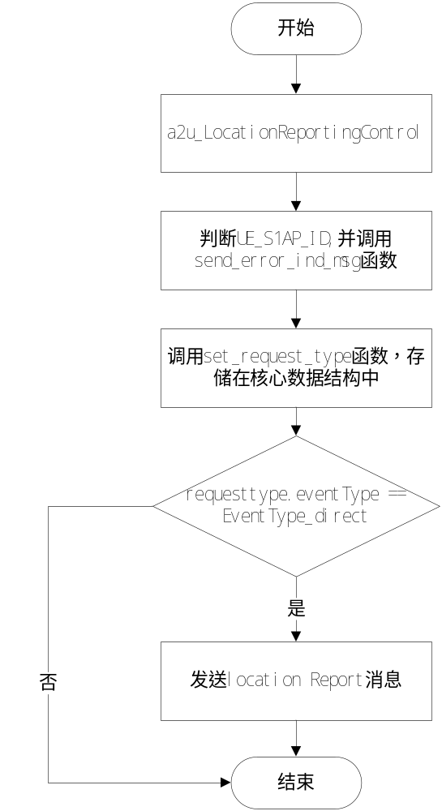

3.1.2 测试用例：

测试用例：eNB_S1_LRP_0001
说明 | 在核心数据结构中没有RequestType时，测试待测函数能否将RequestType函数存储在核心数据结构中
输入 | rnti=62;  INT8 lrc1[] = { 0x00, 0x1F, 0x40, 0x14, 0x00, 0x00, 0x03, 0x00, 0x00,  0x00, 0x02, 0x00, 0x0C, 0x00, 0x08, 0x00, 0x02, 0x00,  0x3E, 0x00, 0x62, 0x40, 0x01, 0x00};
预期输出 | 1 打印出输入的Location Reporting Control消息；  2打印出处理该消息之前，rnti entity中关于RequestType的信息；  3 打印出处理该消息之后，rnti entity中关于RequestType的信息；  4 打印出构造好的Location Report消息的二进制数据流

测试修改
测试方法
将编码好的Location Reporting Control消息和rnti的值传入待测函数，其中rnti=62，打印出处理该消息前后，核心数据结构中关于RequestType的相关信息，通过对比来看RequestType是否存入核心数据结构中，并根据打印出的Location Report消息的二进制数据流，否正确的构造出Location Report消息
测试输出
***********************************************case 1***************************************************
<S1AP-PDU>
<initiatingMessage>
<procedureCode>31</procedureCode>
<criticality><ignore/></criticality>
<LocationReportingControl>
<protocolIEs>
<ProtocolIE-Field>
<id>0</id>
<criticality><reject/></criticality>
<MME-UE-S1AP-ID>12</MME-UE-S1AP-ID>
</ProtocolIE-Field>
<ProtocolIE-Field>
<id>8</id>
<criticality><reject/></criticality>
<ENB-UE-S1AP-ID>62</ENB-UE-S1AP-ID>
</ProtocolIE-Field>
<ProtocolIE-Field>
<id>98</id>
<criticality><ignore/></criticality>
<RequestType>
<eventType><direct/></eventType>
<reportArea><ecgi/></reportArea>
</RequestType>
</ProtocolIE-Field>
</protocolIEs>
</LocationReportingControl>
</initiatingMessage>
</S1AP-PDU>
before handling the Location report control msg:

The RequestType in the rnti entity:
<RequestType>
<eventType><change-of-serve-cell/></eventType>
<reportArea><ecgi/></reportArea>
</RequestType>
size = 46:0021402a00000500000002000c00080002003e00644008007d7f816161626000434006007d7f816e6c0062400100
INFO:[S1_TNL]../source/s1ap/s1_core.c:242 in s1ap_tx_msg: failed to put message queue
ERROR:[S1AP]../source/s1ap/henb/location_reporting_procedure.c:314 in send_location_report: transport Location Report msg failed !

after handling the Location report control msg:

The RequestType in the rnti entity:
<RequestType>
<eventType><direct/></eventType>
<reportArea><ecgi/></reportArea>
</RequestType>
BUG描述
序号 | BUG描述 | 修改情况 | 其他说明

测试用例：eNB_S1_LRP_0002
说明 | 在核心数据结构中存在RequestType 时，测试待测函数能否将RequestType函数存储在核心数据结构中
输入 | rnti=62;  INT8 lrc1[] = { 0x00, 0x1F, 0x40, 0x14, 0x00, 0x00, 0x03, 0x00, 0x00,  0x00, 0x02, 0x00, 0x0C, 0x00, 0x08, 0x00, 0x02, 0x00,  0x3E, 0x00, 0x62, 0x40, 0x01, 0x00};
预期输出 | 1 打印出输入的Location Reporting Control消息；  2打印出处理该消息之前，rnti entity中关于RequestType的信息；  3 打印出处理该消息之后，rnti entity中关于RequestType的信息；

测试修改
测试方法
将编码好的Location Reporting Control消息和rnti的值传入待测函数，其中rnti=62，打印出处理该消息前后，核心数据结构中关于RequestType的相关信息，通过对比来看RequestType是否存入核心数据结构中
测试输出
***********************************************case 2***************************************************
<S1AP-PDU>
<initiatingMessage>
<procedureCode>31</procedureCode>
<criticality><ignore/></criticality>
<LocationReportingControl>
<protocolIEs>
<ProtocolIE-Field>
<id>0</id>
<criticality><reject/></criticality>
<MME-UE-S1AP-ID>12</MME-UE-S1AP-ID>
</ProtocolIE-Field>
<ProtocolIE-Field>
<id>8</id>
<criticality><reject/></criticality>
<ENB-UE-S1AP-ID>62</ENB-UE-S1AP-ID>
</ProtocolIE-Field>
<ProtocolIE-Field>
<id>98</id>
<criticality><ignore/></criticality>
<RequestType>
<eventType><direct/></eventType>
<reportArea><ecgi/></reportArea>
</RequestType>
</ProtocolIE-Field>
</protocolIEs>
</LocationReportingControl>
</initiatingMessage>
</S1AP-PDU>
before handling the Location report control msg:

The RequestType in the rnti entity:
<RequestType>
<eventType><change-of-serve-cell/></eventType>
<reportArea><ecgi/></reportArea>
</RequestType>

after handling the Location report control msg:

The RequestType in the rnti entity:
<RequestType>
<eventType><direct/></eventType>
<reportArea><ecgi/></reportArea>
</RequestType>
BUG描述
序号 | BUG描述 | 修改情况 | 其他说明

测试用例：eNB_S1_LRP_0003
说明 | 测试在错误的MME_UE_S1AP_ID时，待测函数的处理（本例用于提高覆盖率）
输入 | Rnti = 62;  /*wrong MME_UE_S1AP_ID*/  INT8 lrc2[] = { 0x00, 0x1F, 0x40, 0x14, 0x00, 0x00, 0x03, 0x00, 0x00,  0x00, 0x02, 0x00, 0x0A, 0x00, 0x08, 0x00, 0x02, 0x00,  0x3E, 0x00, 0x62, 0x40, 0x01, 0x00};
预期输出 | 1 打印出输入的Location Reporting Control消息；  2 send error indication msg for Location Reporting Control (unknow mme ue s1ap id)failed!（消息队列未开）

测试修改
测试方法
将编码好的Location Reporting Control消息和rnti的值传入待测函数，其中rnti=62，传入的消息中MME_UE_S1AP_ID设置的值为10，而在S1 entity中的对应的值为12，看待测函数能否打印出错的信息，并发送error indication消息
测试输出
***********************************************case 3***************************************************
<S1AP-PDU>
<initiatingMessage>
<procedureCode>31</procedureCode>
<criticality><ignore/></criticality>
<LocationReportingControl>
<protocolIEs>
<ProtocolIE-Field>
<id>0</id>
<criticality><reject/></criticality>
<MME-UE-S1AP-ID>10</MME-UE-S1AP-ID>
</ProtocolIE-Field>
<ProtocolIE-Field>
<id>8</id>
<criticality><reject/></criticality>
<ENB-UE-S1AP-ID>62</ENB-UE-S1AP-ID>
</ProtocolIE-Field>
<ProtocolIE-Field>
<id>98</id>
<criticality><ignore/></criticality>
<RequestType>
<eventType><direct/></eventType>
<reportArea><ecgi/></reportArea>
</RequestType>
</ProtocolIE-Field>
</protocolIEs>
</LocationReportingControl>
</initiatingMessage>
</S1AP-PDU>
before handling the Location report control msg:
The RequestType in the Rnti entity is NULL
ERROR:[S1AP]../source/s1ap/henb/location_reporting_procedure.c:146 in action_fn_handle_location_report_ctrl: wrong mme ue s1ap id!(10)
INFO:[S1_TNL]../source/s1ap/s1_core.c:242 in s1ap_tx_msg: failed to put message queue
ERROR:[S1AP]../source/s1ap/henb/error_ind.c:219 in send_error_ind_msg: tx error indication msg failed!
WARNING:[S1AP]../source/s1ap/henb/location_reporting_procedure.c:156 in action_fn_handle_location_report_ctrl: send error indication msg for Location Reporting Control (unknow mme ue s1ap id)failed!
ERROR:[S1AP]../source/main.c:357 in test_lrc: handle location report control msg failed!
BUG描述
序号 | BUG描述 | 修改情况 | 其他说明

测试用例：eNB_S1_LRP_0004
说明 | 测试待测函数在错误的eNB时的处理流程(提高覆盖率)
输入 | Rnti =62;  /*wrong eNB_UE_S1AP_ID*/  INT8 lrc3[] = { 0x00, 0x1F, 0x40, 0x14, 0x00, 0x00, 0x03, 0x00, 0x00,  0x00, 0x02, 0x00, 0x0C, 0x00, 0x08, 0x00, 0x02, 0x00,  0x32, 0x00, 0x62, 0x40, 0x01, 0x00};
预期输出 | 1 打印出输入的Location Reporting Control消息；  2 打印出BUG wrong enb ue s1ap id!(50)

测试修改
若需修改本模块或其它模块源程序，描述理由，修改的位置以及如何修改。
测试方法

测试输出
***********************************************case 4***************************************************
<S1AP-PDU>
<initiatingMessage>
<procedureCode>31</procedureCode>
<criticality><ignore/></criticality>
<LocationReportingControl>
<protocolIEs>
<ProtocolIE-Field>
<id>0</id>
<criticality><reject/></criticality>
<MME-UE-S1AP-ID>12</MME-UE-S1AP-ID>
</ProtocolIE-Field>
<ProtocolIE-Field>
<id>8</id>
<criticality><reject/></criticality>
<ENB-UE-S1AP-ID>50</ENB-UE-S1AP-ID>
</ProtocolIE-Field>
<ProtocolIE-Field>
<id>98</id>
<criticality><ignore/></criticality>
<RequestType>
<eventType><direct/></eventType>
<reportArea><ecgi/></reportArea>
</RequestType>
</ProtocolIE-Field>
</protocolIEs>
</LocationReportingControl>
</initiatingMessage>
</S1AP-PDU>
before handling the Location report control msg:
The RequestType in the Rnti entity is NULL
ERROR:[S1AP]../source/s1ap/henb/location_reporting_procedure.c:140 in action_fn_handle_location_report_ctrl: BUG wrong enb ue s1ap id!(50)
ERROR:[S1AP]../source/main.c:386 in test_lrc: handle location report control msg failed!
BUG描述
序号 | BUG描述 | 修改情况 | 其他说明

3.2 被测函数：
INT32 send_location_report_fail_indi(Rnti rnti, Cause_t *cause)

3.2.1 函数描述：
功能
构造Location report failure Indication消息，并放入消息队列中
输入
rnti UE的唯一标识
cause cause的指针
输出
返回
成功 S1_LRC_ERR_OK
失败 S1_LRC_ERR_PARAM
算法与处理流程
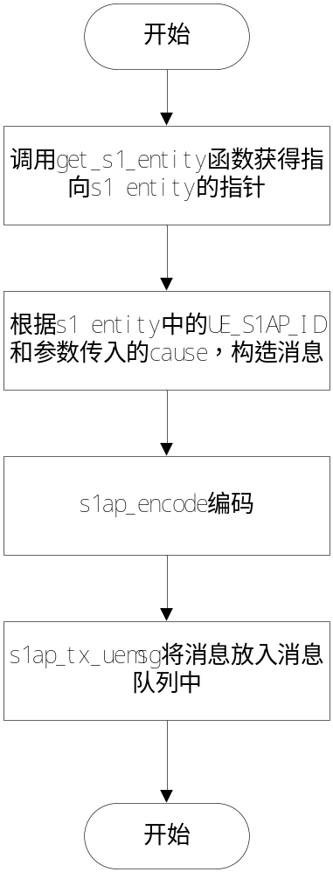

测试用例：eNB_S1_LRP_0005
说明 | 测试待测函数能否构造出Location Report Failure Indication 消息，并放入消息队列中
输入 | Rnti =62;  Cause的地址  {  cause.present = Cause_PR_radioNetwork;  cause.choice.radioNetwork =CauseRadioNetwork_tx2relocoverall_expiry;}
预期输出 | 打印出构造好的Location Report Failure Indication消息

测试修改
测试方法
将rnti的值和cause的地址传给待测函数，能待测函数能否正常的构造出Location Report Failure Indication 消息，并将其放入消息队列中
测试输出
***********************************************case 5***************************************************
size = 25:0020401500000300000002000c00080002003e000240020020
INFO:[S1_TNL]../source/s1ap/s1_core.c:242 in s1ap_tx_msg: failed to put message queue
ERROR:[S1AP]../source/s1ap/henb/location_reporting_procedure.c:226 in send_location_report_fail_indi:
transport Location Report Failure Indication msg failed !
ERROR:[S1AP]../source/main.c:405 in test_lrc: send location report failure indication msg failed!
通过OSS解码后：
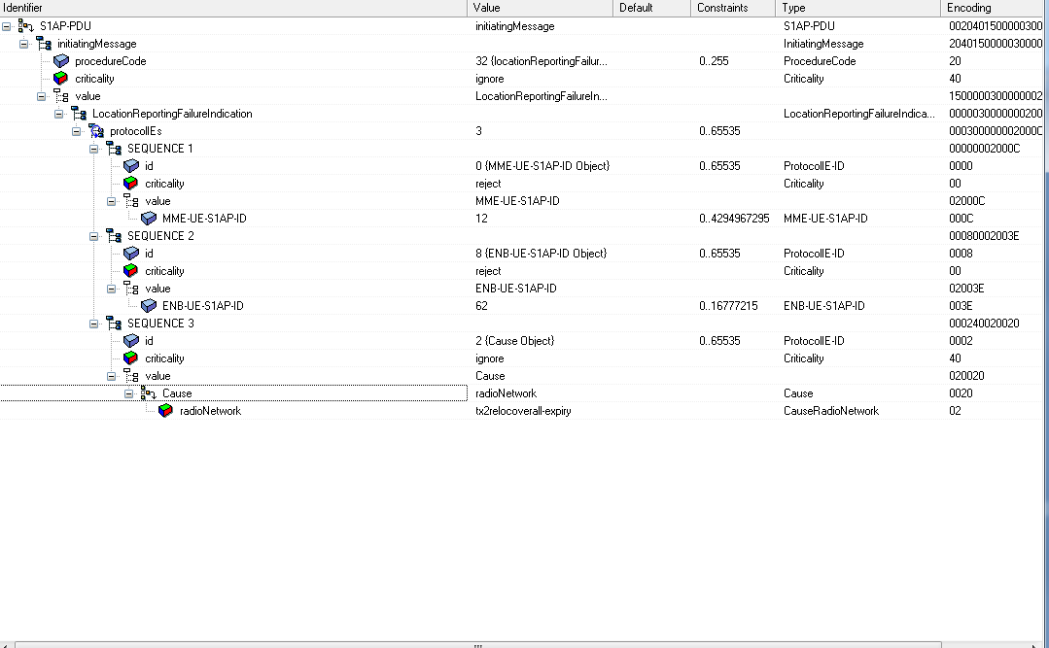
BUG描述
序号 | BUG描述 | 修改情况 | 其他说明

3.3被测函数：
INT32 send_location_report(Rnti rnti)

3.1.1 函数描述：
功能
构造Location Report消息，并将该消息放入消息队列中
输入
rnti UE的唯一标识
输出
返回
成功 S1_LRC_ERR_OK
失败 S1_LRC_ERR_PARAM
算法与处理流程
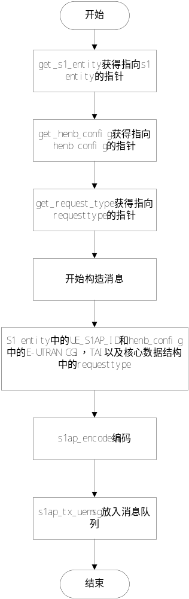

3.1.2 测试用例：

测试用例：eNB_S1_LRP_0006
说明 | 测试待测函数能否正常的构造Location Report消息，并将其放入消息队列中
输入 | Rnti =62;
预期输出 | 打印出构造好的Location Report消息的二进制数据流

测试修改
测试方法
构造了一个rnti entity，将并构造其中的RequestType,同样也构造一个henb_config,将其中构造Location Report消息所需要的E-UTRAN CGI和TAI分别填上值，然后将rnti=62传入待测函数，即可
测试输出
***********************************************case 6***************************************************
size = 46:0021402a00000500000002000c00080002003e00644008007d7f816161626000434006007d7f816e6c0062400108
INFO:[S1_TNL]../source/s1ap/s1_core.c:242 in s1ap_tx_msg: failed to put message queue
ERROR:[S1AP]../source/s1ap/henb/location_reporting_procedure.c:295 in send_location_report: transport Location Report msg failed !
ERROR:[S1AP]../source/main.c:460 in test_lrc: send location report msg failed!
通过OSS解码之后：
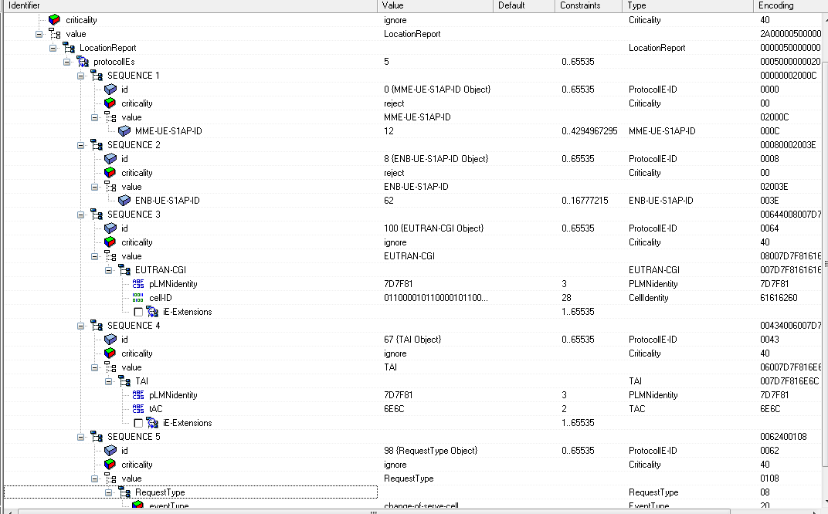
BUG描述
序号 | BUG描述 | 修改情况 | 其他说明

4 覆盖率测试

5 其他测试
==1665==
==1665== HEAP SUMMARY:
==1665== in use at exit: 4,937 bytes in 48 blocks
==1665== total heap usage: 293 allocs, 245 frees, 11,861 bytes allocated
==1665==
==1665== 25 bytes in 1 blocks are definitely lost in loss record 4 of 26
==1665== at 0x4A05E1C: malloc (vg_replace_malloc.c:195)
==1665== by 0x48B5EE: s1ap_tx_msg (s1_core.c:229)
==1665== by 0x48B7DC: s1ap_tx_uemsg (s1_core.c:253)
==1665== by 0x48846B: send_location_report_fail_indi (location_reporting_procedure.c:236)
==1665== by 0x4E674E: test_lrc (main.c:468)
==1665== by 0x4E68AD: main (main.c:517)
==1665==
==1665== 32 bytes in 1 blocks are definitely lost in loss record 5 of 26
==1665== at 0x4A05E1C: malloc (vg_replace_malloc.c:195)
==1665== by 0x48B5EE: s1ap_tx_msg (s1_core.c:229)
==1665== by 0x48B7DC: s1ap_tx_uemsg (s1_core.c:253)
==1665== by 0x48127A: send_error_ind_msg (error_ind.c:218)
==1665== by 0x4881BE: action_fn_handle_location_report_ctrl (location_reporting_procedure.c:152)
==1665== by 0x4E6533: test_lrc (main.c:428)
==1665== by 0x4E68AD: main (main.c:517)
==1665==
==1665== 46 bytes in 1 blocks are definitely lost in loss record 9 of 26
==1665== at 0x4A05E1C: malloc (vg_replace_malloc.c:195)
==1665== by 0x48B5EE: s1ap_tx_msg (s1_core.c:229)
==1665== by 0x48B7DC: s1ap_tx_uemsg (s1_core.c:253)
==1665== by 0x488827: send_location_report (location_reporting_procedure.c:311)
==1665== by 0x488278: action_fn_handle_location_report_ctrl (location_reporting_procedure.c:174)
==1665== by 0x4E6278: test_lrc (main.c:378)
==1665== by 0x4E68AD: main (main.c:517)
==1665==
==1665== 46 bytes in 1 blocks are definitely lost in loss record 10 of 26
==1665== at 0x4A05E1C: malloc (vg_replace_malloc.c:195)
==1665== by 0x48B5EE: s1ap_tx_msg (s1_core.c:229)
==1665== by 0x48B7DC: s1ap_tx_uemsg (s1_core.c:253)
==1665== by 0x488827: send_location_report (location_reporting_procedure.c:311)
==1665== by 0x488278: action_fn_handle_location_report_ctrl (location_reporting_procedure.c:174)
==1665== by 0x4E63D4: test_lrc (main.c:403)
==1665== by 0x4E68AD: main (main.c:517)
==1665==
==1665== 46 bytes in 1 blocks are definitely lost in loss record 11 of 26
==1665== at 0x4A05E1C: malloc (vg_replace_malloc.c:195)
==1665== by 0x48B5EE: s1ap_tx_msg (s1_core.c:229)
==1665== by 0x48B7DC: s1ap_tx_uemsg (s1_core.c:253)
==1665== by 0x488827: send_location_report (location_reporting_procedure.c:311)
==1665== by 0x4E67B2: test_lrc (main.c:479)
==1665== by 0x4E68AD: main (main.c:517)
==1665==
==1665== 46 bytes in 1 blocks are definitely lost in loss record 12 of 26
==1665== at 0x4A05E1C: malloc (vg_replace_malloc.c:195)
==1665== by 0x48B5EE: s1ap_tx_msg (s1_core.c:229)
==1665== by 0x48B7DC: s1ap_tx_uemsg (s1_core.c:253)
==1665== by 0x488827: send_location_report (location_reporting_procedure.c:311)
==1665== by 0x4E67B2: test_lrc (main.c:479)
==1665== by 0x4E68C1: main (main.c:519)
==1665==
==1665== 48 bytes in 1 blocks are definitely lost in loss record 17 of 26
==1665== at 0x4A05E1C: malloc (vg_replace_malloc.c:195)
==1665== by 0x4422E4: sequence_copy (asn_copy.c:68)
==1665== by 0x442925: asn_copy (asn_copy.c:249)
==1665== by 0x487E25: set_request_type (location_reporting_procedure.c:63)
==1665== by 0x488222: action_fn_handle_location_report_ctrl (location_reporting_procedure.c:164)
==1665== by 0x4E6278: test_lrc (main.c:378)
==1665== by 0x4E68AD: main (main.c:517)
==1665==
==1665== 48 bytes in 1 blocks are definitely lost in loss record 18 of 26
==1665== at 0x4A05E1C: malloc (vg_replace_malloc.c:195)
==1665== by 0x4422E4: sequence_copy (asn_copy.c:68)
==1665== by 0x442925: asn_copy (asn_copy.c:249)
==1665== by 0x487E25: set_request_type (location_reporting_procedure.c:63)
==1665== by 0x488222: action_fn_handle_location_report_ctrl (location_reporting_procedure.c:164)
==1665== by 0x4E63D4: test_lrc (main.c:403)
==1665== by 0x4E68AD: main (main.c:517)
==1665==
==1665== 240 bytes in 5 blocks are definitely lost in loss record 20 of 26
==1665== at 0x4A05E1C: malloc (vg_replace_malloc.c:195)
==1665== by 0x4E5BD6: test_create_rnti_entity (main.c:256)
==1665== by 0x4E5FDD: test_lrc (main.c:347)
==1665== by 0x4E68AD: main (main.c:517)
==1665==
==1665== 272 bytes in 1 blocks are possibly lost in loss record 21 of 26
==1665== at 0x4A05140: calloc (vg_replace_malloc.c:418)
==1665== by 0x3AC380FE62: _dl_allocate_tls (in /lib64/ld-2.5.so)
==1665== by 0x3AC4806EB8: pthread_create@@GLIBC_2.2.5 (in /lib64/libpthread-2.5.so)
==1665== by 0x3AC7C05977: __start_helper_thread (in /lib64/librt-2.5.so)
==1665== by 0x3AC480C082: pthread_once (in /lib64/libpthread-2.5.so)
==1665== by 0x3AC7C04AAB: timer_create@@GLIBC_2.3.3 (in /lib64/librt-2.5.so)
==1665== by 0x4454EE: create_timer_internal (lte_timer.c:64)
==1665== by 0x558292: create_rrc_entity (rrc_core.c:445)
==1665== by 0x409465: create_ue_entity (henb_core.c:1223)
==1665== by 0x4E5FD3: test_lrc (main.c:346)
==1665== by 0x4E68AD: main (main.c:517)
==1665==
==1665== 2,429 (2,128 direct, 301 indirect) bytes in 7 blocks are definitely lost in loss record 26 of 26
==1665== at 0x4A05E1C: malloc (vg_replace_malloc.c:195)
==1665== by 0x4E5D72: test_create_henb_config (main.c:296)
==1665== by 0x4E5FF1: test_lrc (main.c:349)
==1665== by 0x4E68AD: main (main.c:517)
==1665==
==1665== LEAK SUMMARY:
==1665== definitely lost: 2,705 bytes in 20 blocks
==1665== indirectly lost: 301 bytes in 14 blocks
==1665== possibly lost: 272 bytes in 1 blocks
==1665== still reachable: 1,659 bytes in 13 blocks
==1665== suppressed: 0 bytes in 0 blocks
==1665== Reachable blocks (those to which a pointer was found) are not shown.
==1665== To see them, rerun with: --leak-check=full --show-reachable=yes
==1665==
==1665== For counts of detected and suppressed errors, rerun with: -v
==1665== Use --track-origins=yes to see where uninitialised values come from
==1665== ERROR SUMMARY: 13 errors from 12 contexts (suppressed: 4 from 4)

6 附录1 测试类型

1. 等价类划分
等价类划分是一种典型的黑盒测试方法。等价类是指某个输入域的集合。它表示对揭露程序中的错误来说，集合中的每个输入条件是等效的。因此我们只要在一个集合中选取一个测试数据即可。等价类划分的办法是把程序的输入域划分成若干等价类，然后从每个部分中选取少数代表性数据当作测试用例。这样就可使用少数测试用例检验程序在一大类情况下的反映。
在考虑等价类时，应该注意区别以下两种不同的情况：
有效等价类：有效等价类指的是对程序的规范是有意义的、合理的输入数据所构成的集合。在具体问题中，有效等价类可以是一个，也可以是多个。
无效等价类：无效等价类指对程序的规范是不合理的或无意义的输入数据所构成的集合。对于具体的问题，无效等价类至少应有一个，也可能有多个。
确定等价类有以下几条原则：
如果输入条件规定了取值范围或值的个数，则可确定一个有效等价类和两个无效等价类。例如，程序的规范中提到的输入条包括“……项数可以从1到999……”，则可取有效等价类为“l考项数＜999”，无效等价类为“项数＜l，，及“项数＞999”。
输入条件规定了输入值的集合，或是规定了“必须如何”的条件，则可确定一个有效等价类和一个无效等价类。如某程序涉及标识符，其输入条件规定“标识符应以字母开头……”则“以字母开头者”作为有效等价类，“以非字母开头”作为无效等价类。
如果我们确知，已划分的等价类中各元素在程序中的处理方式是不同的，则应将此等价类进一步划分成更小等价类。

输入条件 | 有效等价类 | 无效等价类
。。。。。。  。。。。。。 | 。。。。。。  。。。。。。 | 。。。。。。  。。。。。。
根据已列出的等价类表，按以下步骤确定测试用例：
为每个等价类规定一个唯一的编号；
设计一个测试用例，使其尽可能多地覆盖尚未覆盖的有效等价类。重复这一步，最后使得所有有效等价类均被测试用例所覆盖；
设计一个新的测试用例，使其只覆盖一个无效等价类。重复这一步，使所有无效等价类均被覆盖。这里强调每次只覆盖一个无效等价类。这是因为一个测试用例中如果含有多个缺陷，有可能在测试中只发现其中的一个，另一些被忽视。等价类划分法能够全面、系统地考虑黑盒测试的测试用例设计问题，但是没有注意选用一些“高效的”、“有针对性的”测试用例。后面介绍的边值分析法可以弥补这一缺点。

2. 边值分析法
边值分析法是列出单元功能、输入、状态及控制的合法边界值和非法边界值，设计测试用例，包含全部边界值的方法。典型地包括IF语句中的判别值，定义域、值域边界，空或畸形输入，末受控状态等。边值分析法不是一类找一个例子的方法，而是以边界情况的处理作为主要目标专门设计测试用例的方法。另外，边值分析不仅考查输入的边值，也要考虑输出的边值。这是从人们的经验得出的一种有效方法。人们发现许多软件错误只是在下标、数据结构和标量值的边界值及其上、下出现，运行这个区域的测试用例发现错误的概率很高。
用边值分析法设计测试用例时，有以下几条原则：
如果输入条件规定了取值范围，或是规定了值的个数，则应以该范围的边界内及刚刚超出范围的边界外的值，或是分别对最大、最小及稍小于最小、稍大于最大个数作为测试用例。如有规范“某文件可包含l至255”个记录……“，则测试用例可选1和255及0和256等。
针对规范的每个输出条件使用原则〔a〕。
如果程序规范中提到的输入或输出域是个有序的集合(如顺序文件、表格等)就应注意选取有序集的第一个和最后一个元素作为测试用例。
分析规范，尽可能找出可能的边界条件。一个典型的边值分析例子是三角形分类程序。选取a，b，c构成三角形三边，“任意两边之和大于第三边”为边界条件。边值分析相等价类划分侧重不同，对等价类划分是一个补充。如上述三角形问题，选取a＝3，b＝4，c＝5，a＝2，b＝4，c＝7则覆盖有效和无效等价类。如果能在等价类划分中注入边值分析的思想。在每个等价类中不只选取一个覆盖用例，而是进而选取该等价类的边界值等价类划分法将更有效，最后可以用边值分析法再补充一些测试用例。

3. 语句覆盖
程序的某次运行一般并不能执行到其中的每一个语句，因此，如果某语句含有一个错误，而它在测试中没执行，这个错误就不可能被发现。为了提高发现错误的可能性，应该在测试时至少要执行程序中的每一个语句。
所谓“语句覆盖”测试标准，它的含义是：选择足够的测试用例，使得程序中每个语句至少都能执行一次。
例子：
Procedure Example(Var A,B,C:real)
begin
if(A>1)and(B=0)
then x:=x/A；
if(A=2)or(x>1)
then x:=x+l
end;
为了使程序中每个语句至少执行一次，只需设计一个能通过路径ace的例子就可以了。例如选择输入数据为：
A=2，B=0，x=3
就可达到“语句覆盖”标准。
显然，语句覆盖是一个比较弱的覆盖标准。如果第一个条件语句中的and错误地写成or，上面的测试用例是不能发现这个错误的，或者是第二个条件语句中x>1误写成x>0，这个测试用例也不能暴露它。我们还可以举出许多错误情况是上述测试数据不能发现的。所以，一般认为“语句覆盖”是很不充分的最低的一种覆盖标准。

4. 判定覆盖
比“语句覆盖”稍强的覆盖标准是“判定覆盖”(或称分支覆盖)。这个标准是：执行足够的测试用例，使得程序中每个判定至少都获得一次“真”值和“假”值，即使得程序中的每一个分文至少都通过一次。
对上面那个例子，如果设计两个测试用例，就可以达到“判定覆盖”的标难。为此，我们可以选择输人数据为：
(1)A=3，B=0，x=l
(2)A=2，B=1，x=3
“判定覆盖”比“语句覆盖”严格，因为如果每个分支都执行过了，自然每个语句也就执行了。

5. 条件覆盖
它的含义是：执行足够的测试用例，使得判定中每个条件获得各种可能的结果。
对于例子程序,我们只需设计以下两个测试用例就可满足这标准：
(1)A＝2，B＝o，x＝4(沿路径ace执行)
(2)A＝1，B＝l，x＝l(沿路径aN执行)
虽然同样只要两个测试用例，但它比判定覆盖中两个测试用例更有效。一般来说，“条件覆盖”比“判定覆盖”强，但是，并不总是如此，满足“条件覆盖”不一定满足“判定覆盖”。例如对语句。
IF(A AND B)THEN S
设计两个测试用例：A“真”B“假”和A“假”B“真”。对于上例我们设计两个测试用例为：
(1)A＝1，B＝o，x＝3
(2)A＝2，B＝l，x＝1
亦是如此，它们能满足“条件覆盖”但不满足“判定覆盖”。

6. 判定／条件覆盖
针对上面的问题引出了另一种覆盖标准，这就是“判定／条件覆盖”，它的含义是：执行足够的测试用例，同时满足判定覆盖和条件覆盖的要求。显然，它比“判定覆盖”和“条件覆盖”都强。
对于例子程序，我们选取测试用例：
(1)A=2，B=0，x=4
(2)A=1，B=l，x=l
它满足判定／条件覆盖标准。
值得指出，看起来“判定／条件覆盖”似乎是比较合理的，应成为我们的目标，但是事实并非如此，因为大多数计算机不能用一条指令对多个条件作出判定，而必须将源程序中对多个条件的判定分解成几个简单判定。这个讨论说明了，尽管“判定／条件覆盖”看起来能使各种条件取到所有可能的值，但实际上并不一定能检查到这样的程度。针对这种情况，有下面的条件组合覆盖标准。

7. 条件组合覆盖
“条件组合覆盖”的含义是：执行足够的测试用例，使得每个判定中条件的各种可能组合都至少执行一次。这是一个最强的逻辑覆盖标准。
再看例子程序，必须使测试用例覆盖八种组合结果
(1)A>1，B=0 (5)A=2，x>1
(2)A>1，B<>0 (6)A=2，x<1
(3)A<l，B=0 (7)A<>2，x>1
(4)A<1，B<>0 (8)A<>2，x<1
必须注意到，(5)、(6)、(7)、(8)四种情况是第二个条件语句的条件组合，而x的值在该语句之前是要经过计算的，所以我们还必须根据程序的逻辑推算出在程序的人口点x的输入值应是什么。
要测试八个组合结果并不是意味着需要八种测试用例，事实上，我们能用四种测试用例来覆盖它们：
(1)A＝2，B＝o，x＝4；
(2)A＝2，B＝1，x＝l；
(3)A＝l，B＝o，x＝2；
(4)A＝1，B＝1，x＝l。
上面四个例子虽然满足条件组合覆盖，但并不能覆盖程序中的每一条路径，可以看出条件组合覆盖仍然是不彻底的，在白盒测试时，要设法弥补这个缺陷。

